Oak Creek Fire Protection District April 14th, 2026 6:30 p.m.
131 E. Main St, Oak Creek
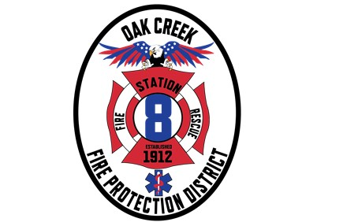
AGENDA
Notice is hereby given that a Regular Meeting of the District Board, of the Oak Creek Fire Protection District, Routt County, Colorado, will be held on Tuesday, April 14, 2026.
Agenda is subject to change up to 24 hours before scheduled hearings
This regular board meeting will be held in person
Join Zoom Meeting
https://us06web.zoom.us/j/82709512898?pwd=NwAJKx8oGOur9SpxGeAEjXH0ihbLrM.1
Call to Order:
- Roll Call
Community Input:
Agenda Modification Consideration
Approval of Minutes:
- Review and consideration for approval from last meeting

Financials:
- Review and approve current financials
- Report Finance Committee
- Municipal Asset Management lease configuration

Fire Chief Search Committee Update
- Town Hall: Finalist for Chief Gary Gula

Other Business:
- Colorado Wildfire Resiliency Code:
  - A motion for the adoption of the 2025 Colorado Wildfire Resiliency Code.

Chief’s Report:
- Crews & Calls- Structure
- Mitigation & Deployments
- Disposal of Surplus Equipment
  - Sale of 5 Surplus Type 3 Engines
  - Temporary Housing Structure

Board of Director’s Highs and Lows
Next Regular Meeting: May 12th, 2026
Adjournment:

